23AI2003 –Artificial Intelligence for Web Development Lab
URK23CS5003

Ex. No: 05 | Javscript Timers/Objects

Aim

To develop a JavaScript Event Countdown Timer that displays the remaining time to a future event and updates dynamically every second.

Description

The application allows users to interact with dynamic web features using JavaScript, including a quiz system and an event countdown timer. Users can attempt multiple-choice questions within a specified time limit, where the interface updates in real time and automatically submits responses when the timer expires. Additionally, the application displays the remaining time for an upcoming event by calculating the difference between the current date and a predefined future date. The countdown is continuously updated every second, and appropriate messages are shown when time limits are reached. This experiment demonstrates the use of JavaScript timing functions such as setInterval() and clearInterval(), along with DOM manipulation to create interactive and time-based web applications.

Code
<!DOCTYPE html>
<html>
<head>
<title>Quiz + Event Countdown</title>
</head>
<body>

<h2>Event Countdown Timer</h2>
<p id="eventTimer"></p>

<hr>

<h2>Quiz App</h2>

<p id="quizTimer">Time: 10</p>
<p id="warning" style="color:red;"></p>

<form id="quizForm">

<p>1. Capital of India?</p>
<input type="radio" name="q1" value="a"> Delhi
<input type="radio" name="q1" value="b"> Mumbai

<p>2. 2 + 2 = ?</p>
<input type="radio" name="q2" value="a"> 4
<input type="radio" name="q2" value="b"> 5

<p>3. Sun rises from?</p>
<input type="radio" name="q3" value="a"> East
<input type="radio" name="q3" value="b"> West

<p>4. HTML stands for?</p>
<input type="radio" name="q4" value="a"> Hyper Text Markup Language
<input type="radio" name="q4" value="b"> High Text Machine Language

<p>5. JS is used for?</p>
<input type="radio" name="q5" value="a"> Styling
<input type="radio" name="q5" value="b"> Logic

<br><br>
<button type="button" onclick="submitQuiz()">Submit</button>

</form>

<p id="result"></p>

<script>
/* ================= EVENT COUNTDOWN ================= */

let eventDate = new Date("April 10, 2026 12:00:00").getTime();

let eventTimer = setInterval(function() {

let now = new Date().getTime();
let distance = eventDate - now;

let days = Math.floor(distance / (1000 * 60 * 60 * 24));
let hours = Math.floor((distance % (1000 * 60 * 60 * 24)) / (1000 * 60 * 60));
let minutes = Math.floor((distance % (1000 * 60 * 60)) / (1000 * 60));
let seconds = Math.floor((distance % (1000 * 60)) / 1000);

document.getElementById("eventTimer").innerHTML =
days + "d " + hours + "h " + minutes + "m " + seconds + "s ";

if (distance < 0) {
clearInterval(eventTimer);
document.getElementById("eventTimer").innerHTML = "Registration Closed";
}

}, 1000);

/* ================= QUIZ TIMER ================= */

let time = 10;
let quizTimer = setInterval(updateQuizTimer, 1000);

function updateQuizTimer() {
document.getElementById("quizTimer").innerText = "Time: " + time;

if (time == 5) {
document.getElementById("warning").innerText = "Only 5 seconds remaining!";
}

if (time == 0) {
clearInterval(quizTimer);
submitQuiz();
}
time--;
}

/* ================= QUIZ LOGIC ================= */

function submitQuiz() {
clearInterval(quizTimer);

let answers = {
q1: "a",
q2: "a",
q3: "a",
q4: "a",
q5: "b"
};

let score = 0;
let form = document.forms["quizForm"];

for (let q in answers) {
if (form[q].value == answers[q]) {
score++;
}
}

document.getElementById("result").innerText = "Score: " + score;

let inputs = document.querySelectorAll("input");
inputs.forEach(i => i.disabled = true);
}
</script>

</body>
</html>

Input & Output
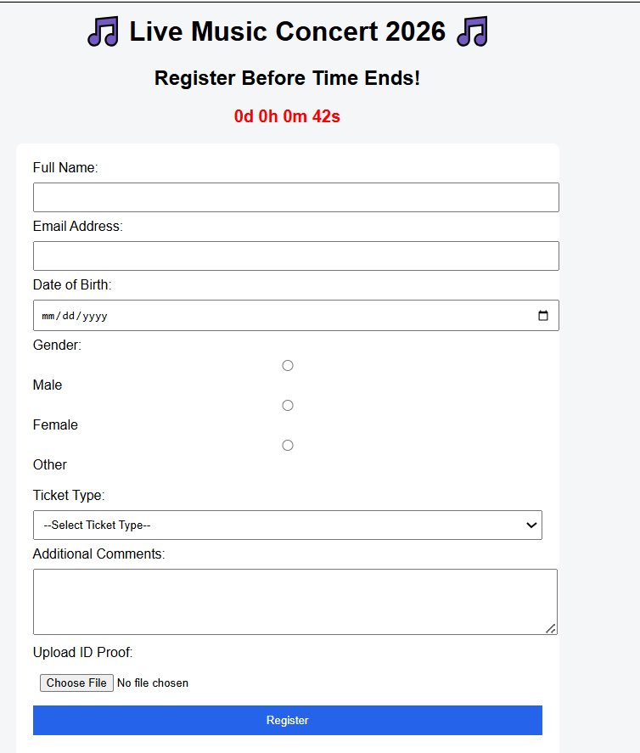
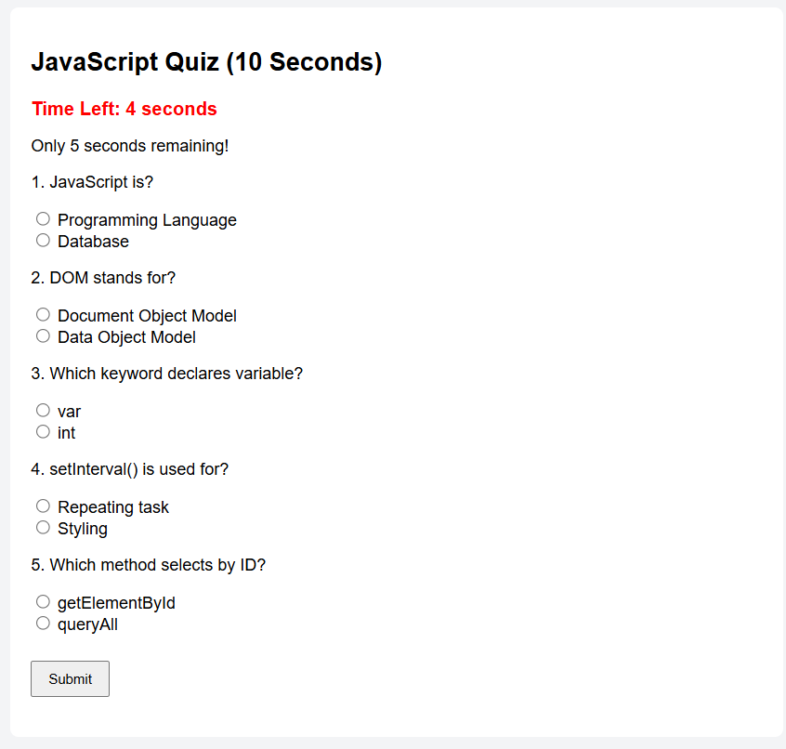

Result
The experiment was successfully completed.

